
ImageArchive
Archive Master Images to Disc

ImageArchive is an add-on module for ImageCopy that enables the storage of DDP and CMF images on recordable disc.

Features
Built on Proven Technology
ImageArchive uses Eclipse’s industry-standard analysis and copy engine to ensure that every master is thoroughly checked during the archiving process. In addition, ImageArchive incorporates the confidence and safety provided by ImageIntegrity’s checksum and bit-for-bit verification. Detailed log files are created and stored on every image for future reference. This proven technology produces archival masters than can be trusted and depended on.
Seamless Integration
ImageArchive fits into your existing process perfectly. Archive discs can be created using the standard ImageCopy user interface that is familiar to your operators . ImageArchive’s dual-output feature allows the incoming master to be loaded to the mastering network and archived to disc in the same operation. All copies are analyzed and verified. ImageArchive minimizes additional training and process modification and can be implemented with ease.
Total Process Solution
Eclipse has incorporated archive support into all EclipseSuite programs. EclipseSuite programs now scan for ImageArchive masters and properly process the image without the risks associated with mishandling the archive disc. Archive masters are also supported by ImageEncoder and ImageNet Schedulers and can incorporate ImageIntegrity Signatures for replica verification.

Archival of masters has become an increasing necessity for many replication facilities. This is due partly to the emergence of electronic content delivery in the replication workflow. When masters arrive without physical media, it is up to the replicator to store the data offline for re-work and for anti-piracy compliance. Archiving to disc is also gaining acceptance because of the high cost and time associated with making, copying and storing DLTs. Migrating to a recordable disc archive format saves significant expense and time.
Whatever your archiving purpose, ImageArchive allows you to archive your masters simply, with total confidence, and with very little impact on your existing process.

Applications

- Send inexpensive disc archive masters instead of DLTs when outsourcing or offloading to save money.
- Store disc archive masters instead of DLTs in the library to save space.
- Use high-speed disc archive masters instead of DLTs for data verification to save time.
- Replace obsolete DLT drives with DVD writers.
- Send disc archive masters instead of Redbook masters to replication to mimimize errors

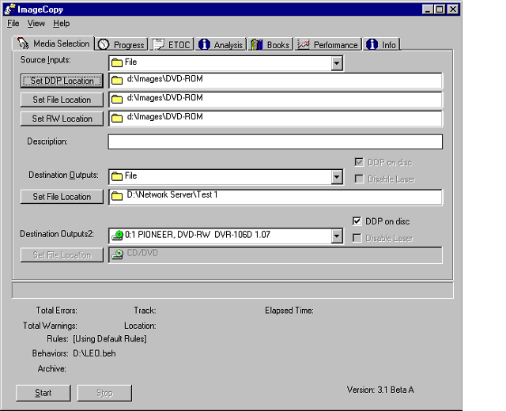
\
Dual output mode combines archiving with Premastering.
System Requirements:
- Windows 2000/XP
- PIII 1GHz or higher
- ImageCopy and ImageIntegrity, version 4.0 or higher.
- Supported Input and Output drives

Supported Formats:
- All CD Formats
- All DVD Formats
(Requires DVD enabled ImageCopy)
Create archive discs by checking a box!
- Source can tape, disk or file¹

List of supported devices can be found at http://www.eclipsedata.com/products/peripherals/matrix.htm

